The Harbor Ridge Homeowner
A Publication of the Harbor Ridge Homeowners Association SPRING 2013
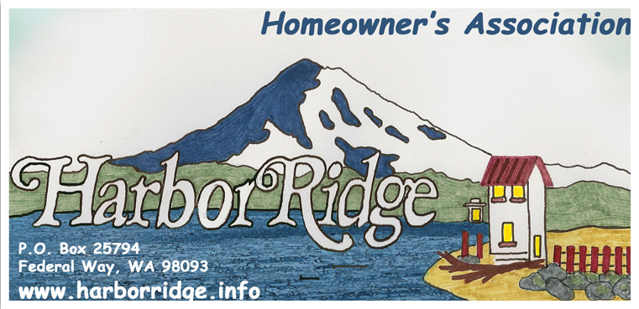
Spring is here . . . more or less. Several days of clear blue skies and welcome sunshine reminds us that our lawns and landscaping are emerging from winter’s hibernation. Not so welcome, for those of us who are decidedly NOT avid gardeners, is the pending cycle of home and yard maintenance. A good gauge that some work may be needed is the pesky yellow flowers that pop up everywhere, even in driveway and sidewalk cracks!

One effective way to deal with the grass and weeds that seem only to grow out of the sidewalk expansion joints or the division between cement curb and asphalt roadway is a two step process. First, clear offending vegetation with a string trimmer. Next scrounge around in the garage for a paint roller and a bucket. Pour your ‘Round-Up’ in the bucket and then use the paint roller, preferably attached to an extension pole so you don’t have to crawl around on your knees, to roll round-up into the cracks. You will be satisfied that no dead patches mysteriously appear in your lawn from blowing Round-Up and the weeds take several months to start creeping back.

This is a good time to take stock of your landscaping vegetation. If any is blocking sidewalks, now is the time to trim it back. We too are emerging from hibernation and more of us will be out walking the dogs or just walking to enjoy the weather; the sidewalks are our by-ways. Those of us who live on street corners should look to see if trees or shrubs block driver’s view of oncoming traffic. Please trim any offending foliage. Each day brings more and more children of all ages riding bicycles, scooters, skate boarding or just gathering to socialize in and around our neighborhood. Their safety and other driver’s safety are at stake.

Your homeowner’s association maintains three small plots of landscaping. Labor costs to improve and maintain these plots are paid from member’s dues. If your dues payment is in arrears please catch up. We, the board try to maintain these plots ourselves to keep costs low. If you feel an urge to weed or water our community property, please do so. It will certainly help your neighbors and us by maintaining attractive entrances to our neighborhoods. Suggestions for improvement are always welcome. Please attend regularly scheduled association meetings or contact any board member with your ideas. Check out our website, www.harborridge.info/ for a list of all board members and contact information.

Spring clean up always reminds us that all home owners within Harbor Ridge boundaries agreed to abide by our covenants, conditions, and restrictions. (CC&Rs). This is an excellent time to review ours to ensure compliance. They are available for your review at www.harborridge.info/. The least desirable duty of the Harbor Ridge Home Owners Association board is managing compliance to CC&Rs. Please make this appalling job unnecessary through self-compliance . . .

Throughout the winter all of us have spotted coyotes around the area. Urban coyotes have been around for eons but they appear more aggressive and more prevalent as the years go by. No matter how bad you feel when you spot a bedraggled, gangly, sodden, hound skulking through a miserable wet, snowy, winter day, tail between his legs, remember he is a predator. His favorite food is “Fluffy” your cat or “Spot” your small, cuddly, dog. We have no dogs running loose in Harbor Ridge, but keep the predator coyote in mind when you let Fluffy or Spot out in the back yard to do his business!

Some time ago an effort was made to encourage replacing our individual mailboxes with community, lockable, more secure, boxes. Some folks rallied to the challenge and made the change. Several installations can be examined within Harbor Ridge. Osprey Drive, Cliffside Drive and Harbor Ridge Road are streets where secure mailboxes are located. With most folks skyping, texting, or emailing, safeguarding snail-mail may seem arcane at best or just plain stupid. When someone steals your credit card bill from your traditional mail box and uses it to empty your bank accounts you will think back to this article and ask yourself this: Why didn’t I get with my neighbors and install a secure mail box? If you are interested in upgrading to community, lockable, secure mailboxes on your street, please contact the Harbor Ridge Board for more information in USPS guidelines and regulations.

Anyone hear the fire engines on 25 April? One of our neighbors turned his 1936, Silvertone radio on and promptly forgot about it. Oops! Nothing burned and the smoke damage was minimal, but the incident is a good reminder. Look around and make sure electrical and fire hazards are tended too. This is especially important when you leave for a few days of camping, fishing, or sightseeing.

Have YOU Seen The Community Garden?
We have a community garden in our neighborhood called Garden of Peace. In it's fifth year of operation, Garden of Peace is located on the grounds of Resurrection Lutheran Church. The 22 plots (size 8' X 18') are for "rent" where gardeners can grow vegetables and flowers during the summer. A hoop house was just built on the property to grow veggies in the winter too. There are nine fruit trees and a beehive to help pollinate the trees and the vegetables/flowers. Several garden plots are dedicated to growing food for a food bank in the Hilltop of Tacoma. Garden of Peace is connected to the Tacoma Community Gardens network so they receive free potable Tagro, compost, and wood chips to help amend the soil and walking paths. Come look for yourself. The garden is open to visitors any time. Walk around the garden beds and observe the various plants and techniques people are using to grow. ALL are welcome at Garden of Peace. For more information, please contact Cindy Niemi at (253) 924-1847.

